BS 851

Homework 5

Irene Hsueh

**Question A**

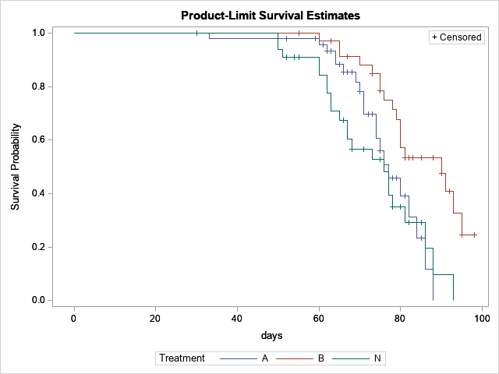

The treatment A group had the first event at 33 days, and then events steadily occur starting at 64 days until the end of the study. Subjects in the treatment B group were most resistant to depression remission; the first event didn’t occur until 60 days. The treatment N group didn’t have an event until 50 days, but a larger proportion of subjects had depression remission from that point on. Treatment N seems to be the best in promoting depression remission, while Treatment B appears to be the worst in doing so.

**Question B**

|  |  |
| --- | --- |
| **Treatment** | **Depression Remission at 70 days** |
| A | 21.97% |
| B | 11.89% |
| N | 56.71% |

**Question C**

|  |  |
| --- | --- |
| **Treatment** | **Median Time to Remission** |
| A | 77 days |
| B | 90 days |
| N | 76 days |

Treatment N appears to be the most effective because it has the least time to depression remission.

**Question D**

H0: The survival distribution for treatments N and A are the same.

H1: The survival distribution for one group is a power of the other.

H0: The survival distribution for treatments N and B are the same.

H1: The survival distribution for one group is a power of the other.

A log-rank test was used to test whether the survival distributions for treatment groups N and A were different. The chi-squared statistic was 0.6112 and the resulting p-value was 0.4343. With a p-value greater than the α=0.05 significance level, the null hypothesis of there being a difference in the survival distributions between treatment groups N and A was not rejected. There is insufficient evidence to conclude that treatment N is more effective for depression remission than treatment A.

A log-rank test was used to test whether the survival distributions for treatment groups N and B were different. The chi-squared statistic was 10.4435 and the resulting p-value was 0.0012. With a p-value less than the α=0.05 significance level, the null hypothesis of there being a difference in the survival distributions between treatment groups N and B was rejected. There is evidence suggesting that treatment N is more effective for depression remission that treatment B.

**Question E**

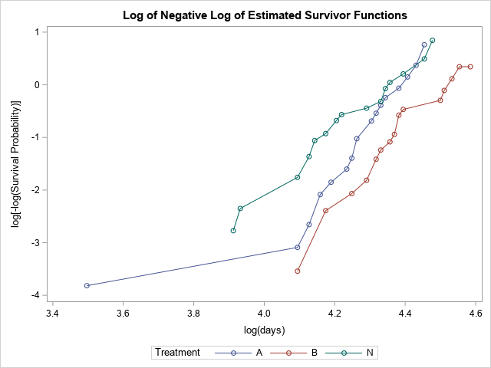

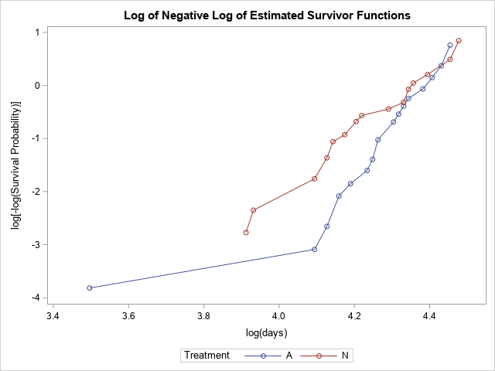

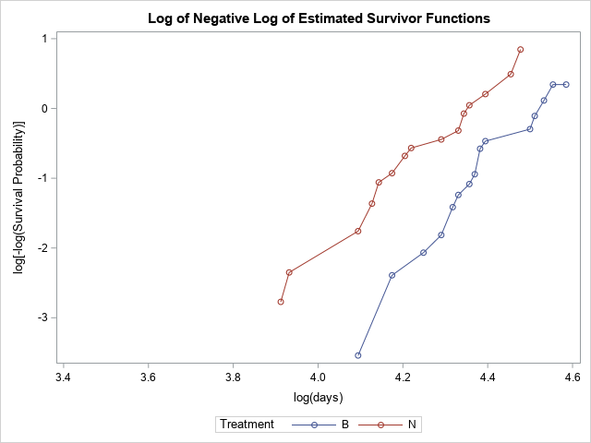

Based on the log-log survival plots, the proportional hazards assumption is met between N and B, but not between N and A because the curves cross a couple of times.

**Question F**

H0: , The hazard ratios for all treatments are the same.

H1: , The hazard ratios for all the treatments are not the same.

A Cox proportional hazards regression analysis was used to test whether the hazard ratios for all the treatments were the same. Comparing treatments N and A, the chi-squared statistic was 0.6433 and the resulting p-value was 0.4225. With a p-value greater than the α=0.05 significance level, the null hypothesis of there being a difference in hazard ratios of treatments N and A was not rejected. The hazard of depression remission for treatment A is 0.778 of the hazard for treatment N (95% confidence interval: 0.421-1.437), but there is insufficient evidence to conclude that treatment N is more effective than treatment A.

Comparing treatments N and B, the chi-squared statistic was 10.7099 and the resulting p-value was 0.0011. With a p-value less than the α=0.05 significance level, the null hypothesis of there being a difference in hazard ratios of treatments N and B was rejected. There is evidence suggesting that the hazard of depression remission for treatment B is 0.338 of the hazard for treatment N (95% confidence interval: 0.177-0.647), making treatment N more effective at bringing about depression remission.

**Question G**

|  |  |
| --- | --- |
| **Treatment** | **Proportion Death** |
| A | 28.26% |
| B | 27.03% |
| N | 26.47% |

A chi-squared test was used to test whether there was a difference in proportion of death between the three treatment groups. The chi-squared statistic was 0.0344 with 2 degrees of freedom and resulting p-value was 0.9830. With a p-value greater than the α=0.05 significance level, the null hypothesis of there being no difference in proportion of death between the treatment groups was not rejected. There is insufficient evidence to conclude that the competing risk of death was different between the three treatment groups.

**Question H**

A Cox proportional hazards regression analysis was used to test whether the hazard ratios for all the treatments were the same. Comparing treatments N and A, the chi-squared statistic was 0.6 and the resulting p-value was 0.423. With a p-value greater than the α=0.05 significance level, the null hypothesis of there being a difference in hazard ratios of treatments N and A was not rejected. The hazard of depression remission for treatment A is 77.8% of the hazard for treatment N (95% confidence interval: 42.1%-143.7%), but there is insufficient evidence to conclude that treatment N is more effective than treatment A.

Comparing treatments N and B, the chi-squared statistic was 10.7 and the resulting p-value was 0.001. With a p-value less than the α=0.05 significance level, the null hypothesis of there being a difference in hazard ratios of treatments N and B was rejected. There is evidence suggesting that the hazard of depression remission for treatment B is 33.8% of the hazard for treatment N (95% confidence interval: 17.7%-64.7%), making treatment N more effective at bringing about depression remission.